Organization of BRG-321: Microelectronic Design and Characterization Lab
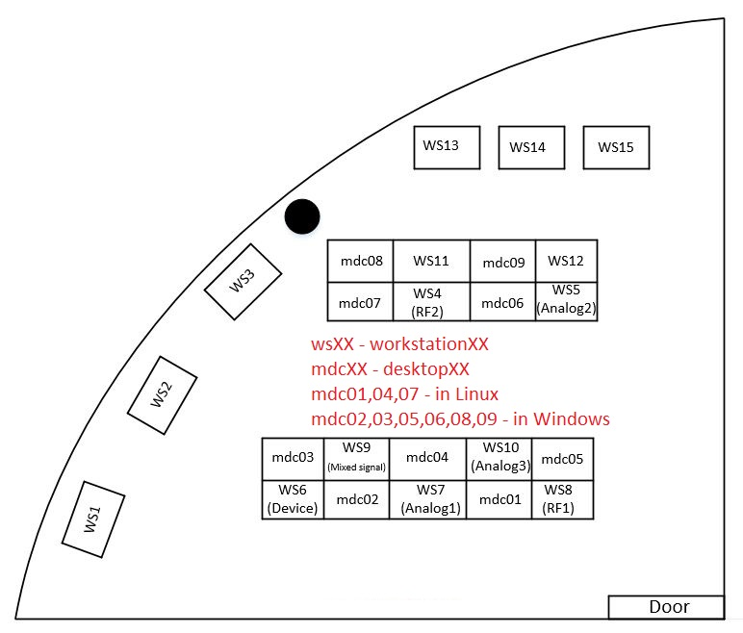

List of Work Stations:
- WORKSTATION1
  - TS150 manual probe station
  - TS200‐SE Analytic Probe Station

- WORKSTATION2
  - TPT HB16 wire bonder

- WORKSTATION3
  - PACE TF1800 rework station

- WORKSTATION4 (RF2)
  - Wideband Scope Infiniium DSA91304A
  - Rohde & Schwarz RF Signal Generator (SMB 100A) (40 GHz)
  - Agilent 81134A Pulse Pattern Gen.
  - Agilent E3630A (3‐ch Power Supply)
  - TTi MX100T DC Power Supply Triple Out.

- WORKSTATION5 (Analog2)
  - Tek MDO/MSO 3024 (4+16, 200MHz)
  - Agilent E3630A (3‐ch Power Supply)
  - TTi MX100T DC Power Supply Triple Out.
  - Arb waveform generator (Keysight 33500B)
  - Keithley 2110-120 Digital Multimeter
  - Keithley Source Meter 2602B
  - KH7008 low noise preamplifiers

- WORKSTATION6 (Device)
  - Keithley 4200 Semiconductor Analyzer System

- WORKSTATION7 (Analog1)
  - Tek MDO/MSO 3024 (4+16, 200MHz)
  - Agilent E3630A (3‐ch Power Supply)
  - Triple Output Programmable DC Power Supply (TTi MX100T)
  - Arb waveform generator (Keysight 33500B)
  - Keithley 2110-120 Digital Multimeter
  - SRS780 spectrum analyzer
  - KH7008 low noise preamplifiers

- WORKSTATION8 (RF1)
  - PNA‐X Microwave Network Analyzer
  - Agilent N5172B (Vector Signal Gen.) 6GHz
  - Keysight MSOX3104
  - Agilent E3630A (3‐ch Power Supply)
  - TTi MX100T DC Power Supply Triple Out.

- WORKSTATION9 (Mixed Signal)
  - Agilent 16852A Logic Analyzer
  - Keysight MSOX3104
  - Agilent E3630A (3‐ch Power Supply)
  - TTi MX100T DC Power Supply Triple Out.
  - Agilent 34401A (Multimeter)
  - Arb waveform generator (Keysight 33611A)

- WORKSTATION10 (Analog3)
  - Tek MDO/MSO 3024 (4+16, 200MHz)
  - Arb waveform generator (Keysight 33611A)
  - Agilent E3630A (3‐ch Power Supply)
  - TTi MX100T DC Power Supply Triple Out.
  - Agilent 34401A (Multimeter)

